**AKNOWLEDGEMENT**

I thank my all in guide , principal rev.fr. Antony Madavanakadu for bestowing his keen generosity in allowing me to effect this project in a refined manner. I also thank our vice principal Mrs. Vinitha Mendez for her immense support.

This project is the product of my shared conviction with my mendor Mrs. Mariamma Thomas that the richness of great thinking and sheer understanding correspondingly merits rich technology , corollary to this conviction is my belief that such technology sounds worth when the viewer or reader appreciates the incredible amount of technical beauty put into the concerned program.

As the outset , I especially am indebted to lord Almighty for flooding his grace and blessings on me in all aspects to terminate this project in fine manner and to the schedule

I would like to appreciate my teammate who worked hard for the success of this project. On a final note thanks to my batch mates who with small but really helpful guidance stood beside me to develop this work.

**CONTENTS**

1. INTRODUCTION
2. SYSTEM REQUIREMENTS AND SPECIFICATIONS
3. FUNCTIONS CREATED
4. SOURCE CODE
5. OUTPUT
6. BIBLIOGRAPHY

**SYSTEM REQUIREMENTS AND SPECIFICATIONS**

1. PROCESSOR – PENTIUM 4
2. SPEED – 2.0 GHZ
3. MEMORY – 256 MB RAM
4. HARD DISK – 20 GB
5. OPERATING SYSTEM – WINDOWS XP OR ABOVE

**DATA DICTIONARY**

TABLE -1:- INPUT DETAILS

|  |  |  |  |  |  |
| --- | --- | --- | --- | --- | --- |
| Field | Type | Null | Key | Default | Extra |
| name1 | varchar(20) | Yes |  | Null |  |
| name2 | varchar(20) | Yes |  | Null |  |
| phone_number | varchar(12) | Yes |  | Null |  |
| place | char(20) | Yes |  | Null |  |
| phone_name | char(20) | Yes |  | Null |  |
| model_number | int(11) | Yes |  | Null |  |

TBALE – 2:- MOBILE SERVICES

|  |  |  |  |  |  |
| --- | --- | --- | --- | --- | --- |
| Field | Type | Null | Key | Default | Extra |
| S_no | Int(11) | yes |  | Nul |  |
| Service_type | char(30) | Yes |  | Null |  |
| Cost | Int(11) | Yes |  | Null |  |
| Service_charge | Int(11) | Yes |  | Null |  |
| total | Int(11) | Yes |  | null |  |

**TABLE – 3:- ORDER DETAILS**

|  |  |  |  |  |  |
| --- | --- | --- | --- | --- | --- |
| Field | Type | Null | Key | Default | Extra |
| Date_of_order | Char(15) | Yes |  | Null |  |
| Name1 | Varchar(20) | Yes |  | Null |  |
| Name2 | Varchar(20) | Yes |  | Null |  |
| Phone_number | Varchar(12) | Yes |  | Null |  |
| place | Char(20) | Yes |  | Null |  |

**SOURCE CODE**

import winsound

from datetime import *

import time

import os

print("\n\t\t PROVIDE YOUR MySQL PASSWORD AND USERNAME")

u=input('\n\t\t\t Enter SQL USERNAME :')

pas=input('\n\t\t\t Enter SQL PASSWORD :')

os.system("cls")

import mysql.connector as mysql

mcon=mysql.connect(host='localhost',user=u,passwd=pas)

mcur=mcon.cursor()

mcur1=mcon.cursor()

mcur2=mcon.cursor()

mcur.execute("create database if not exists project")

mcur.execute("use project")

print("******************************************************************************")

print("------------------------------- Welcome To -----------------------------------")

print("--------------------------- GRAVITY SMARTPHONES ------------------------------")

#input_details table

try:

mcur.execute('create table input_details(name1 varchar(20),name2 varchar(20),phone_number varchar(12),place varchar(20),phone_name varchar(20),model_number int)')

except:

pass

#order_details table

try:

mcur.execute('create table order_details(date_of_order varchar(15),name1 varchar(20),name2 varchar(20),phone_number varchar(12),place varchar(20))')

except:

pass

#mobile_services table

try:

mcur1.execute('create table mobile_services(s_no int,service_type char(30),cost int,service_charge int,total int)')

mcur1.execute('insert into mobile_services values(1,"Protection Glass ",300 ,50 , 350 )')

mcur1.execute('insert into mobile_services values(2,"Display Replacement ",1500,100, 1600)')

mcur1.execute('insert into mobile_services values(3,"Battery Replacement ",2000,100, 2100)')

mcur1.execute('insert into mobile_services values(4,"Camera Lens Change ",6000,200, 6200)')

mcur1.execute('insert into mobile_services values(5,"ChargingPort Repair ",1000,100, 1100)')

mcur1.execute('insert into mobile_services values(6,"Speaker Repair ",1500,100, 1600)')

mcur1.execute('insert into mobile_services values(7,"Warranty Extension ",3500,0 , 3500)')

mcur1.execute('insert into mobile_services values(8,"Complete Mobile Maintenance",5000,0 , 5000)')

mcon.commit()

except:

pass

def add_det():

#add details

os.system("cls")

winsound.PlaySound("SystemQuestion",winsound.SND_ASYNC)

c=input("\n WOULD YOU LIKE TO SEE THE EXISTING SERVICES (y/n)---- :")

print('')

if c=='y' or c=='Y':

mcur1.execute('select * from mobile_services')

print("")

print('{:<7}'.format('S.No'),'{:<28}'.format('Service Type'),'{:<7}'.format('Cost'),'{:<12}'.format('Service Charge'),'{:>11}'.format("Total"))

print("")

while True:

try:

b=mcur1.fetchone()

print('{:<7}'.format(b[0]),'{:<28}'.format(b[1]),'{:<7}'.format(b[2]),'{:>11}'.format(b[3]),'{:>14}'.format(b[4]))

print('')

except:

break

e=input("\n PRESS ENTER TO PROCEED TO ADDING DETAILS ")

s_no=int(input("\n ENTER THE SERVICE NUMBER :"))

service_type=input("\n ENTER THE SERVICE TYPE :")

cost=int(input("\n ENTER THE COST :"))

service_charge=int(input("\n ENTER THE SERVICE CHARGE :"))

total=cost+service_charge

mcur1.execute("insert into mobile_services values(%s,%s,%s,%s,%s)",(s_no,service_type,cost,service_charge,total,))

mcon.commit()

winsound.PlaySound("SystemQuestion",winsound.SND_ASYNC)

c=input("\n WOULD YOU LIKE TO SEE THE SERVICES AFTER EDITING (y/n) :")

print('')

os.system("cls")

if c=='y' or c=='Y':

mcur2.execute('select * from mobile_services')

print("")

print('{:<7}'.format('S.No'),'{:<28}'.format('Service Type'),'{:<7}'.format('Cost'),'{:<12}'.format('Service Charge'),'{:>11}'.format("Total"))

print("")

while True:

try:

b=mcur2.fetchone()

print('{:<7}'.format(b[0]),'{:<28}'.format(b[1]),'{:<7}'.format(b[2]),'{:>11}'.format(b[3]),'{:>14}'.format(b[4]))

print('')

except:

break

else:

print("\n\t\t PRESS ENTER IF YOU LIKE TO PROCEED")

#opt=input("\n\t\t Do You Want to continue....?(y/n) :")

def del_det():

#delete details

winsound.PlaySound("SystemQuestion",winsound.SND_ASYNC)

c=input("\n WOULD YOU LIKE TO SEE THE EXISTING SERVICES (y/n) :")

if c=='y' or c=='Y':

mcur2.execute('select * from mobile_services')

print("")

print('{:<7}'.format('S.No'),'{:<28}'.format('Service Type'),'{:<7}'.format('Cost'),'{:<12}'.format('Service Charge'),'{:>11}'.format("Total"))

print("")

while True:

try:

b=mcur2.fetchone()

print('{:<7}'.format(b[0]),'{:<28}'.format(b[1]),'{:<7}'.format(b[2]),'{:>11}'.format(b[3]),'{:>14}'.format(b[4]))

print('')

except:

break

d=int(input("\n\t\t ENTER THE SERVICE NUMBER YOU WANT TO DELETE :"))

mcur2.execute("delete from mobile_services where s_no=%s",(d,))

mcon.commit()

c=input("\n WOULD YOU LIKE TO SEE THE SERVICES AFTER DELETING (y/n) :")

if c=='y' or c=='Y':

mcur2.execute('select * from mobile_services')

print('')

print('{:<7}'.format('S.No'),'{:<28}'.format('Service Type'),'{:<7}'.format('Cost'),'{:<12}'.format('Service Charge'),'{:>11}'.format("Total"))

print("")

while True:

try:

b=mcur2.fetchone()

print('{:<7}'.format(b[0]),'{:<28}'.format(b[1]),'{:<7}'.format(b[2]),'{:>11}'.format(b[3]),'{:>14}'.format(b[4]))

print('')

except:

break

def ser_details():

mcur1.execute('select * from mobile_services')

print('')

print('{:<7}'.format('S.No'),'{:<28}'.format('Service Type'),'{:<7}'.format('Cost'),'{:<12}'.format('Service Charge'),'{:>11}'.format("Total"))

print("")

while True:

try:

b=mcur1.fetchone()

print('{:<7}'.format(b[0]),'{:<28}'.format(b[1]),'{:<7}'.format(b[2]),'{:>11}'.format(b[3]),'{:>14}'.format(b[4]))

print('')

except:

break

def order():

#details of customer

print("\n REDIRECTING TO CUSTOMER INPUT PAGE .... ")

time.sleep(2)

os.system('cls')

n1=input("\n\t Enter your first name :")

n2=input("\n\t Enter your second name :")

no=input("\n\t Enter your Phone Number :")#mistake

place=input("\n\t Enter your Place :")

pname=input("\n\t Enter your Smart Phone Name :")

model=input("\n\t Enter your Phone Model Number :")

#placing order

print("\n\t REDIRECTING TO PLACING ORDER PAGE .... ")

time.sleep(3)

os.system('cls')

o=int(input("\n\t ENTER YOUR DESIRED ITEM NUMBER :"))

q=int(input("\n\t ENTER DESIRED NUMBER OF QUANTITY :"))

print('\n\t ===== DETAILS YOU HAVE ENQUIRED IS AS FOLLOWS ===== \n')

today=date.today()

#writing into order details

mcur.execute("insert into input_details values(%s,%s,%s,%s,%s,%s)",(n1,n2,no,place,pname,model,))

mcur2.execute("insert into order_details values(%s,%s,%s,%s,%s)",(today,n1,n2,no,place,))

mcon.commit()#writing

mcur.execute("select * from mobile_services where s_no=%s",(o,))

print("")

print('{:<7}'.format('S.No'),'{:<28}'.format('Service Type'),'{:<7}'.format('Cost'),'{:<12}'.format('Service Charge'),'{:>11}'.format("Total"))

print("")

while True:

try:

b=mcur.fetchone()

print('{:<7}'.format(b[0]),'{:<28}'.format(b[1]),'{:<7}'.format(b[2]),'{:>11}'.format(b[3]),'{:>14}'.format(b[4]))

print('')

except:

break

print("\n\t !!! SUCCESSFULLY PLACED YOUR ORDER !!!")

mcur1.execute("select total from mobile_services where s_no=%s",(o,))

winsound.PlaySound("SystemQuestion",winsound.SND_ASYNC)

print('{:>9}'.format('\n\t TOTAL PRICE :'),end='')

e=mcur1.fetchall()

for j in e:

for k in j:

print('{:>9}'.format(k*q),end='')

print("\n\n\t Date of Order :",today)

print('\n')

def cust_hist():

today=date.today()

ot='y' or 'Y'

while ot=='y' or ot=='Y':

print("\n\t\t CHOOSE YOUR OPTION PLEASE .... ")

print("\n\t\t 1. SEE TODAYS ORDER HISTORY ")

print("\n\t\t 2. SEE ORDER HISTORY OF ANOTHER DAYS ")

p=int(input("\n\t\t CHOOSE YOUR CHOICE PLEASE(1/2) :"))

if p==1:

mcur2.execute("select * from order_details where date_of_order=%s",(today,))

print("")

print('{:<15}'.format("Date"),'{:<15}'.format("First Name"),'{:<15}'.format("Last Name"),'{:<12}'.format("Phone No."),'{:<12}'.format("Place"))

print("")

while True:

try:

b=mcur2.fetchone()

print('{:<15}'.format(b[0]),'{:<15}'.format(b[1]),'{:<15}'.format(b[2]),'{:<12}'.format(b[3]),'{:<12}'.format(b[4]))

print('')

except:

break

elif p==2:

d=input("\n\t Enter the Desired Date (yyyy-mm-dd) :")

mcur2.execute("select * from order_details where date_of_order=%s",(d,))

print("")

print('{:<15}'.format("Date"),'{:<15}'.format("First Name"),'{:<15}'.format("Last Name"),'{:<12}'.format("Phone No."),'{:<12}'.format("Place"))

print("")

while True:

try:

b=mcur2.fetchone()

print('{:<15}'.format(b[0]),'{:<15}'.format(b[1]),'{:<15}'.format(b[2]),'{:<12}'.format(b[3]),'{:<12}'.format(b[4]))

print('')

except:

break

ot=input("\n Do yo want to stay in customer history page ...?(y/n) :")

os.system("cls")

opt='y' or 'Y'

while opt=='y' or opt=='Y':

print("\n\t\t CHOOSE YOUR LOGIN TYPE")

print("\n\t\t 1. ADMIN LOGIN ")

print("\n\t\t 2. CUSTOMER LOGIN ")

p=int(input("\n\t\t CHOOSE YOUR CHOICE PLEASE :"))

os.system("cls")

if p==1:

u=input("\n\t\t ENTER USERNAME :")

pw=input("\n\t\t ENTER PASSWORD :")

if (u=="admin" or u=="ADMIN") and pw=="1234":

os.system("cls")

o='y' or 'Y'

while o=='y' or o=='Y':

print("\n\t\t 1. ADD DETAILS ")

print("\n\t\t 2. DELETE DETAILS ")

print("\n\t\t 3. PURCHASE HISTORY DETAILS ")

ch=int(input("\n\t\t ENTER YOUR CHOICE PLEASE :"))

os.system("cls")

if ch==1:

add_det()

elif ch==2:

del_det()

elif ch==3:

cust_hist()

o=input("\n Do You Want to stay in Admin Page ....?(y/n) :")

else:

winsound.PlaySound("SystemQuestion",winsound.SND_ASYNC)

print("\n\t\t SORRY!!! YOUR USERNAME OR PASSWORD WENT WRONG")

print("\n\t\t PLEASE TRY AGAIN !!!.....")

elif p==2:

op='y' or 'Y'

while op=='y' or op=='Y':

print("\n=============================================================================")

print("\n\t\t GRAVIY SMARTPHONE SERVICE LIST ")

print("\n\t\t 1. OUR SERVICES ")

print("\n\t\t 2. PLACE YOUR ORDER ")

print("\n\t\t 3. ABOUT US ")

c=int(input("\n\t\t ENTER YOUR CHOICE(1/2/3) :"))

if c==1:

ser_details()

elif c==2:

order()

elif c==3:

print("\n Gravity Smartphones is an established company since 1989.\n Our company provides with differebt samrtphone services throughout India and also have our branches in 10 different countries.\n The motive of our company is to provide best and trusting services to our customers.\n Our company specialises in most of the smartphone brands and we have our staffs well trained to do out their job.")

op=input("\n Do You Want to Stay in Customer Page....?(y/n) :")

os.system("cls")

continue

else:

continue

opt=input("\n Do You Want To Continue Our Services....?(y/n) :")

os.system("cls")

print("\n\t\t ==== THANK YOU FOR USING OUR SERVICES ===== ")

OUTPUT

**Entering MySql password and user name:**

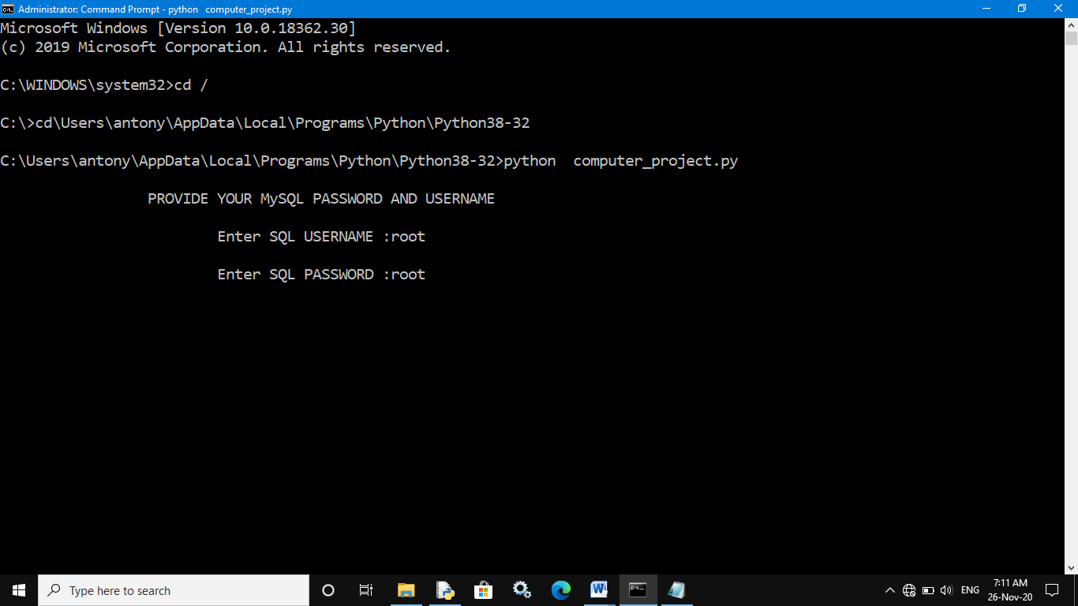

**Welcome page:**

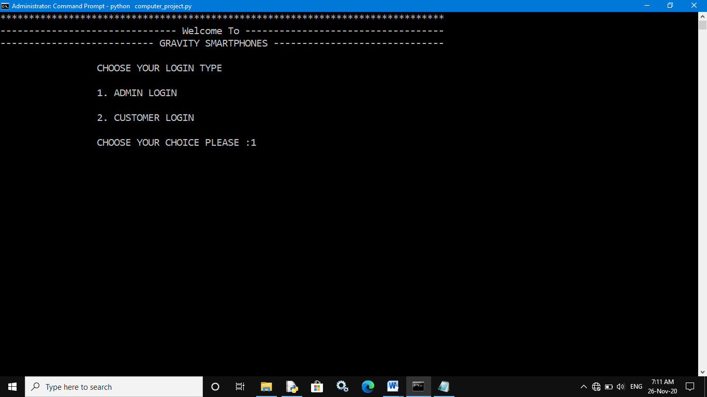

**Admin login:**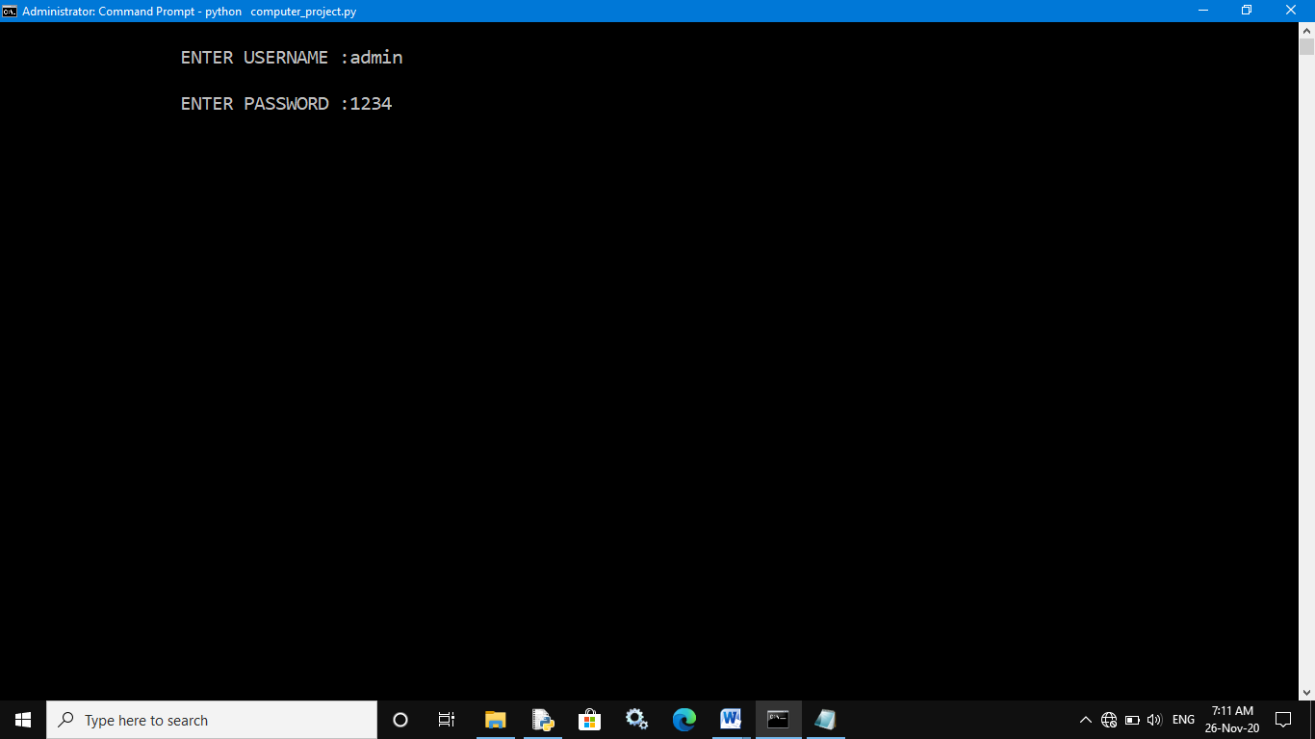

**Admin menu:**

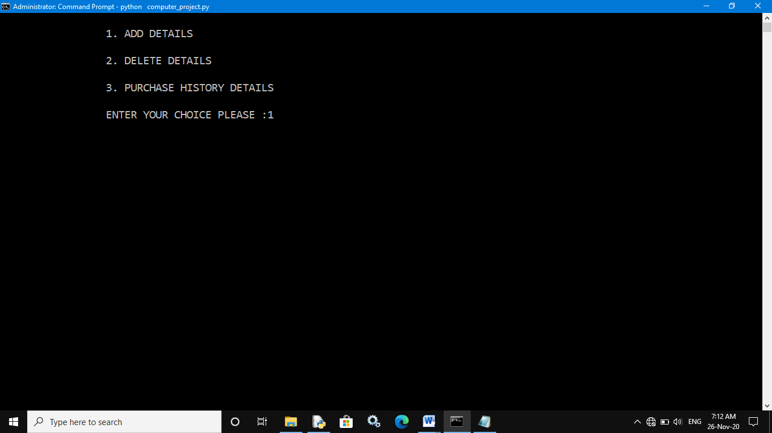

**First choice:**

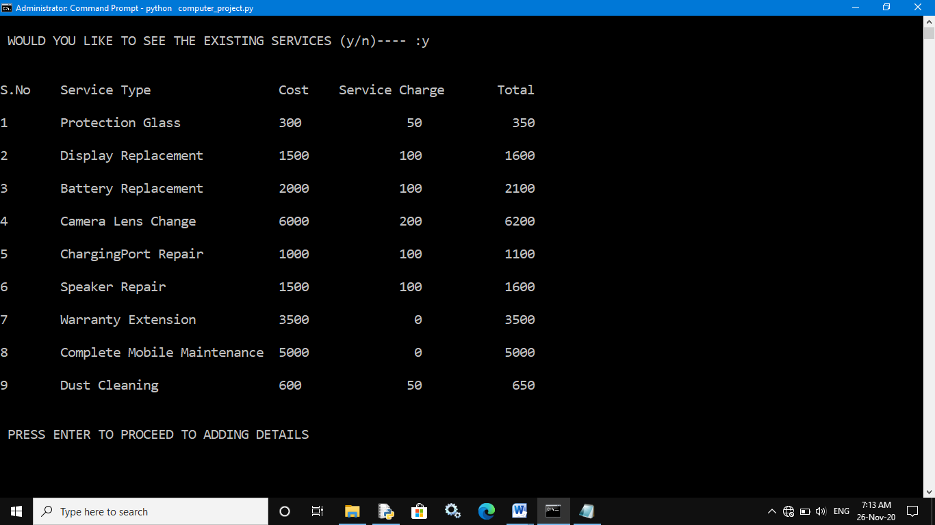

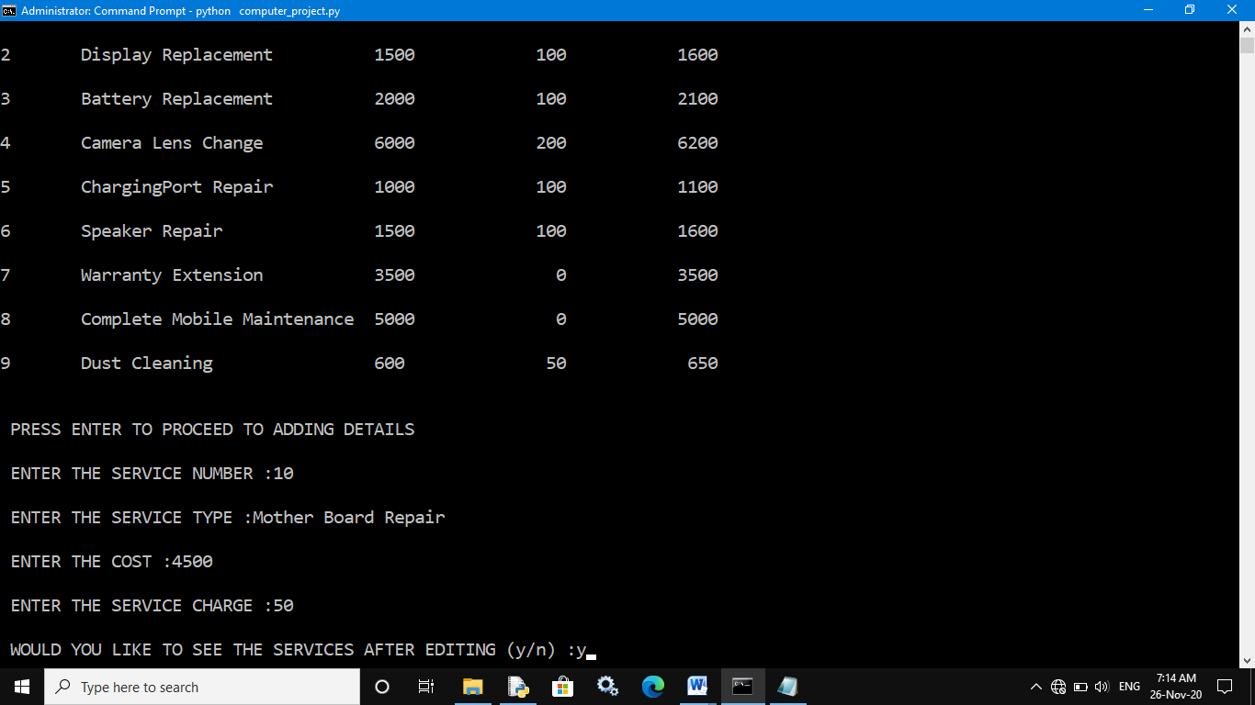

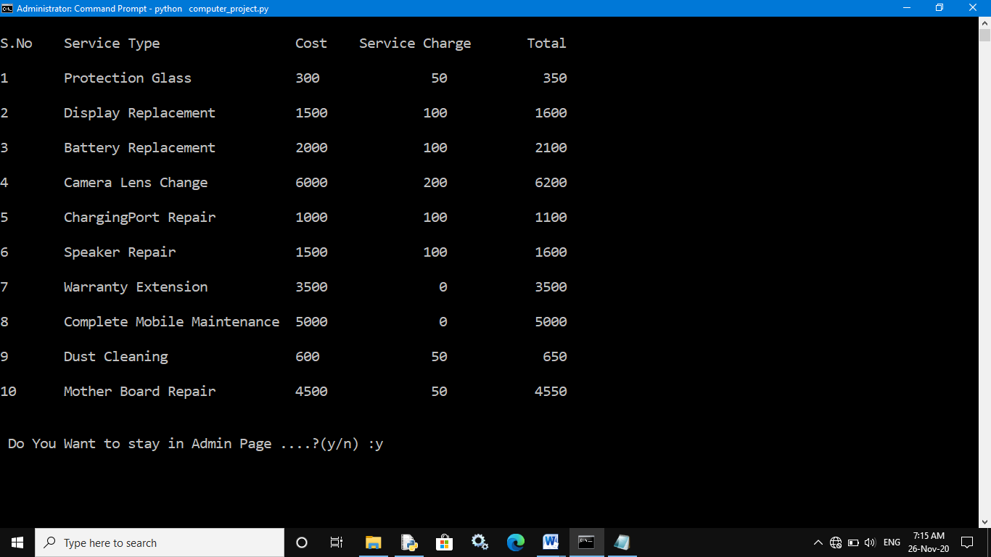

**Second choice:**

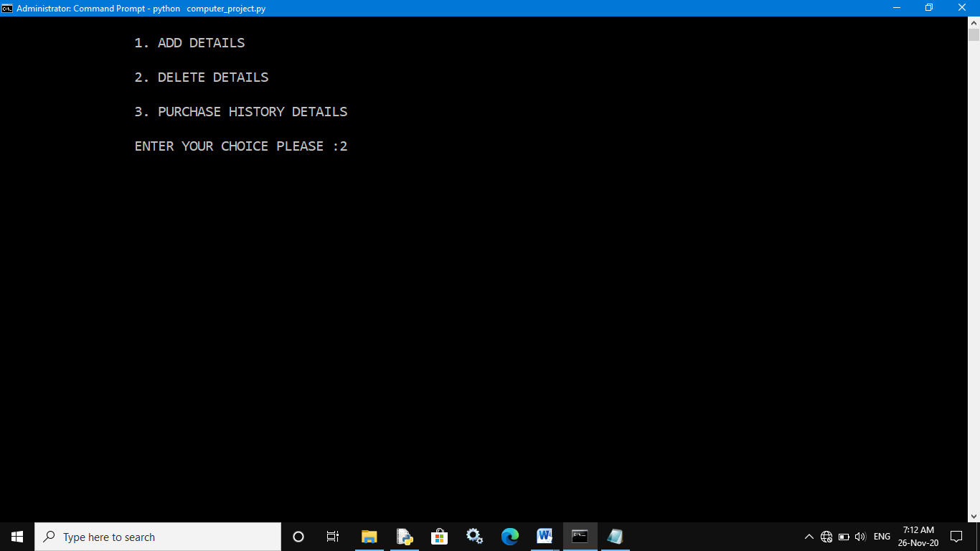

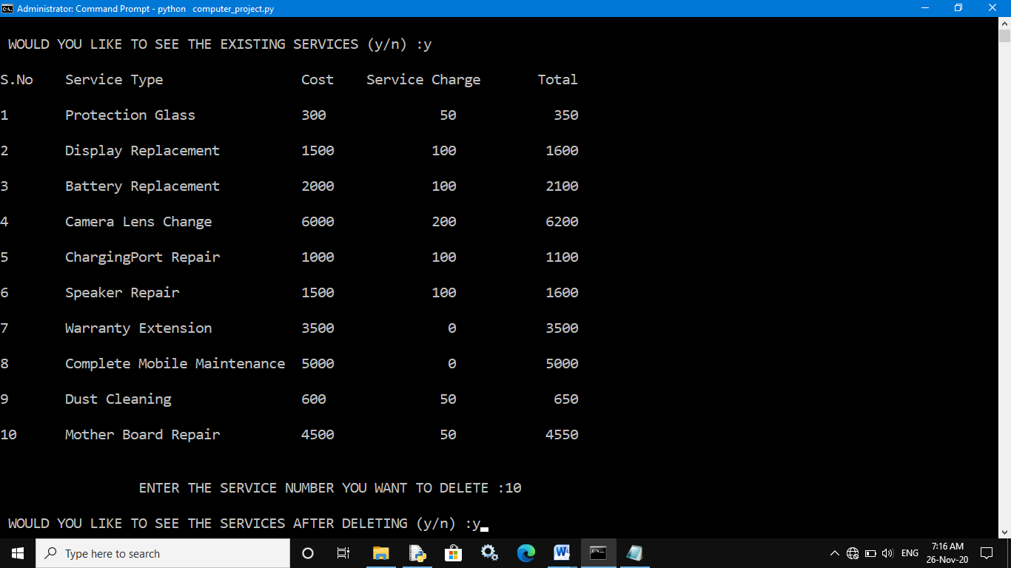

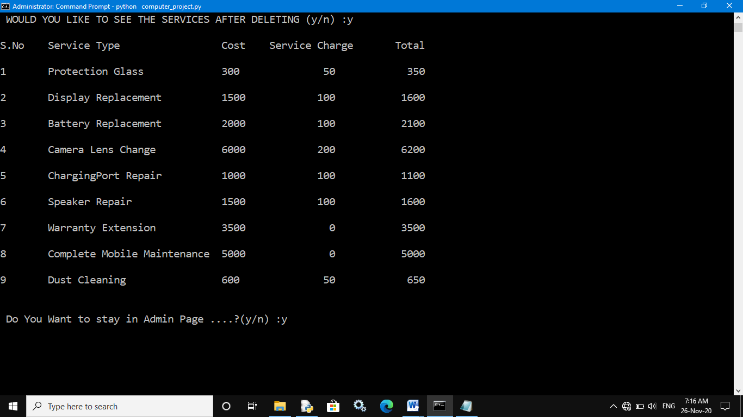

**Third choice:**

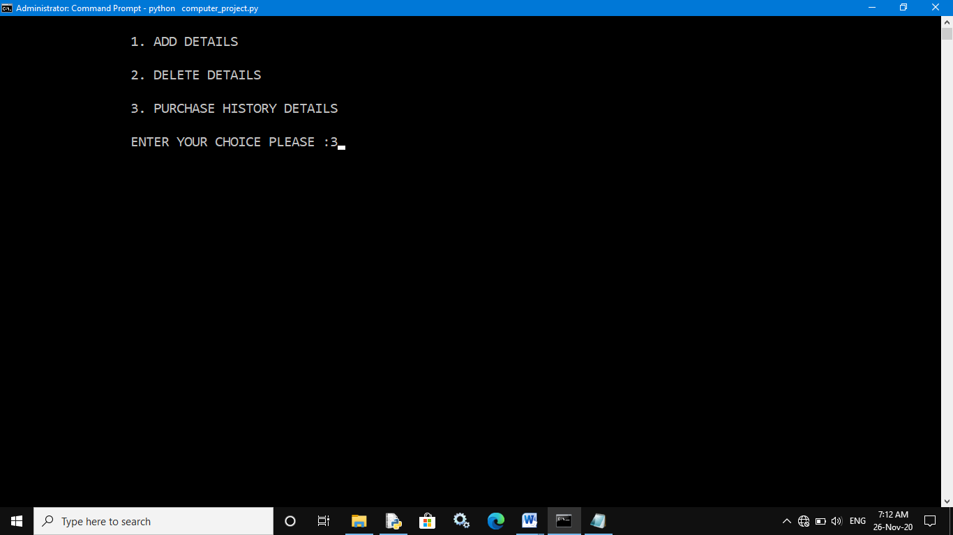

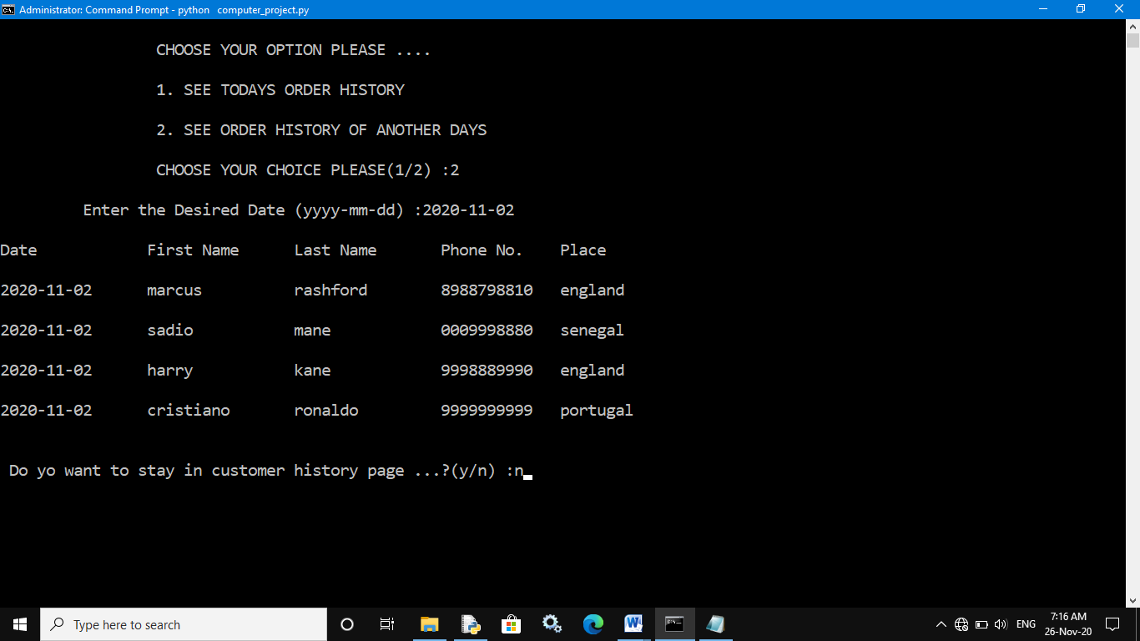

**Exiting from admin page:**

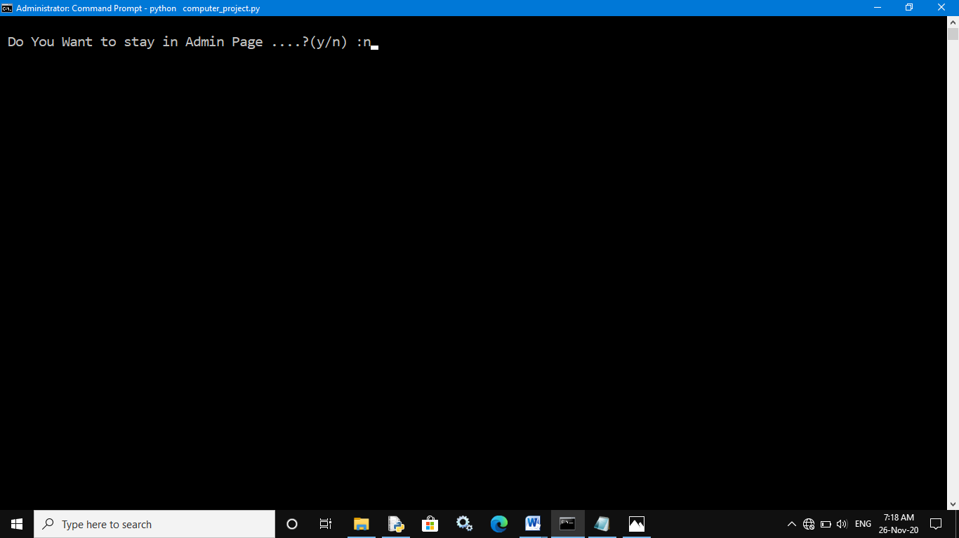

**Continuing the program:**

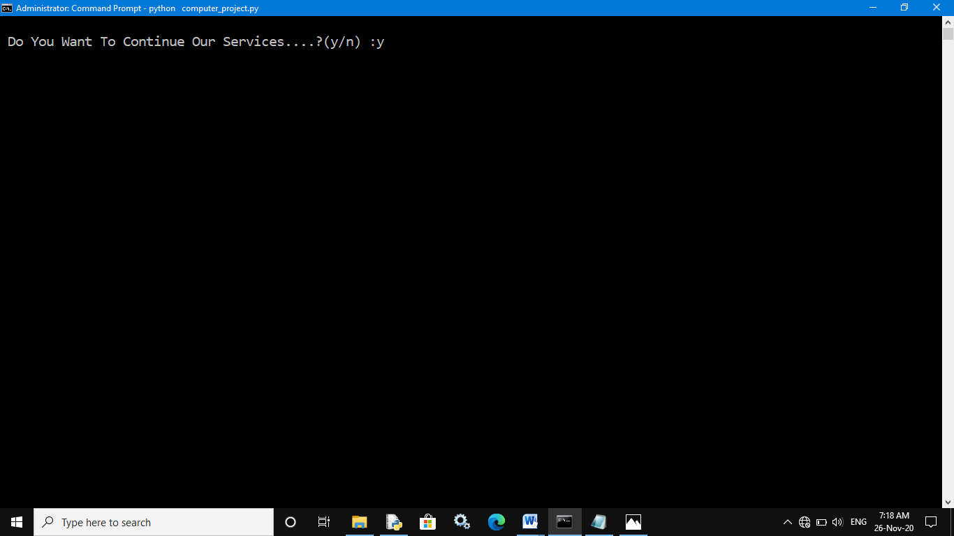

**Choosing Customer login:**

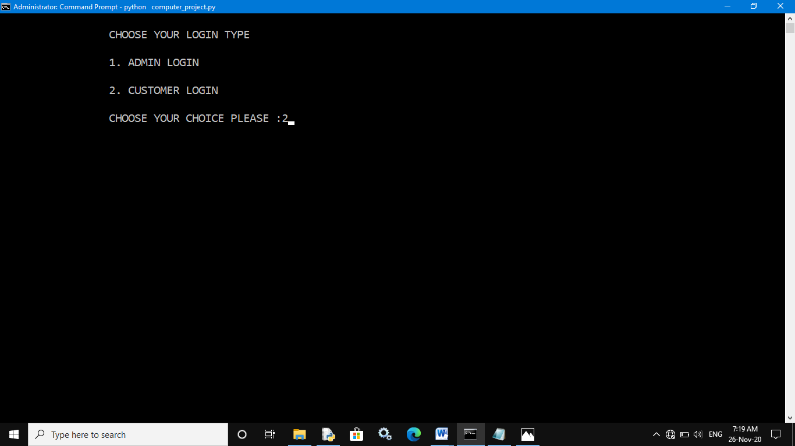

**Customer login menu:**

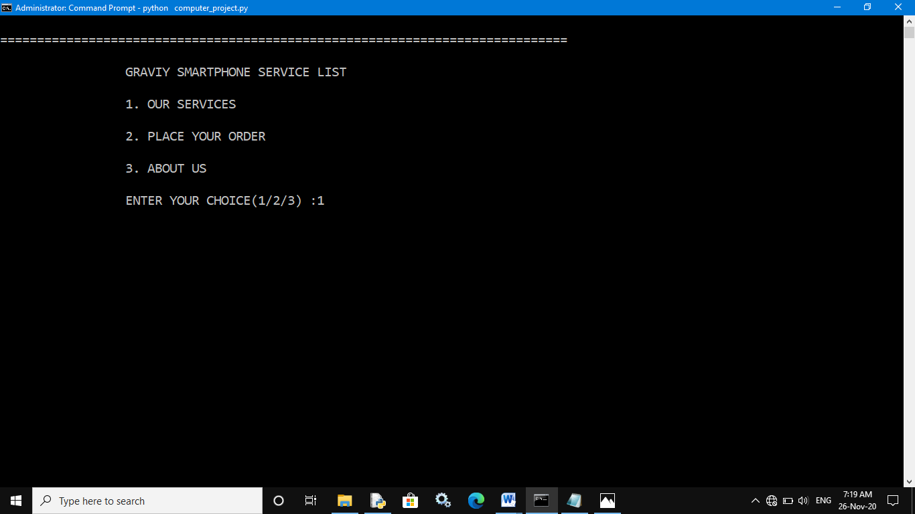

**First choice:**

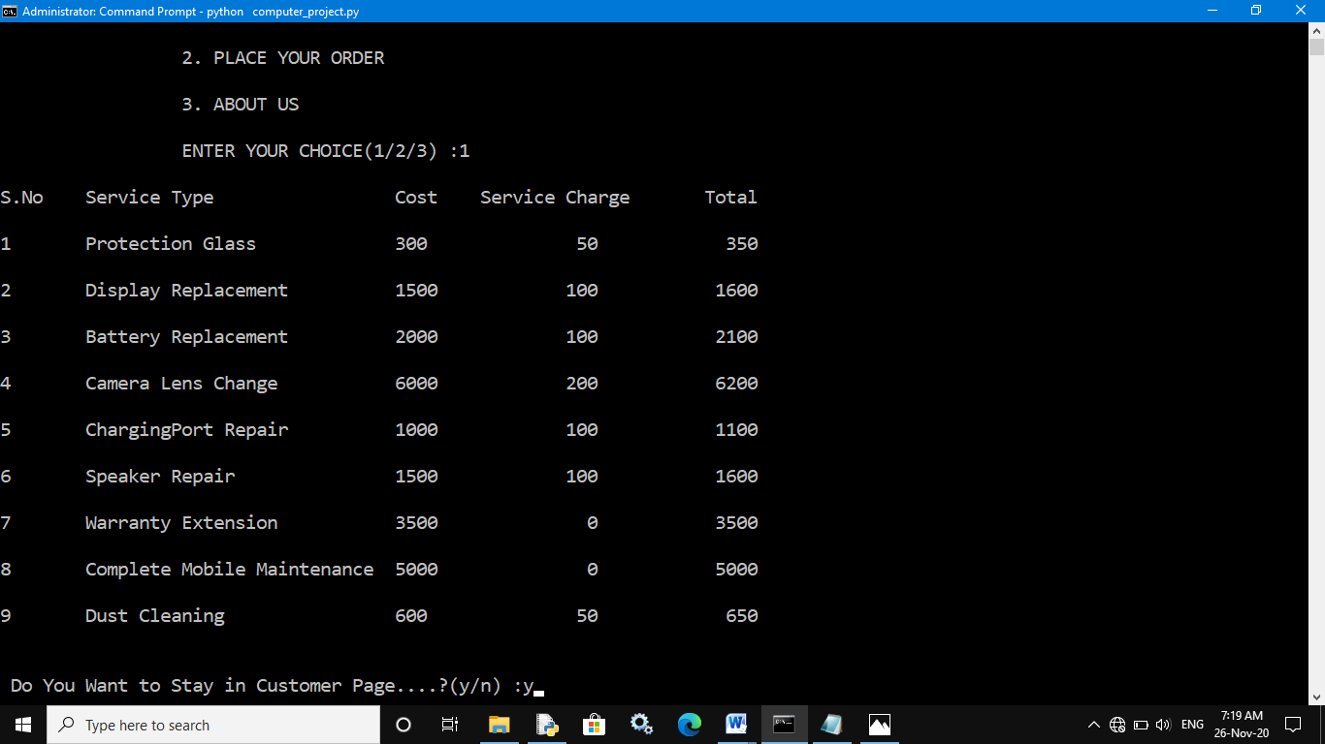

**Second choice:**

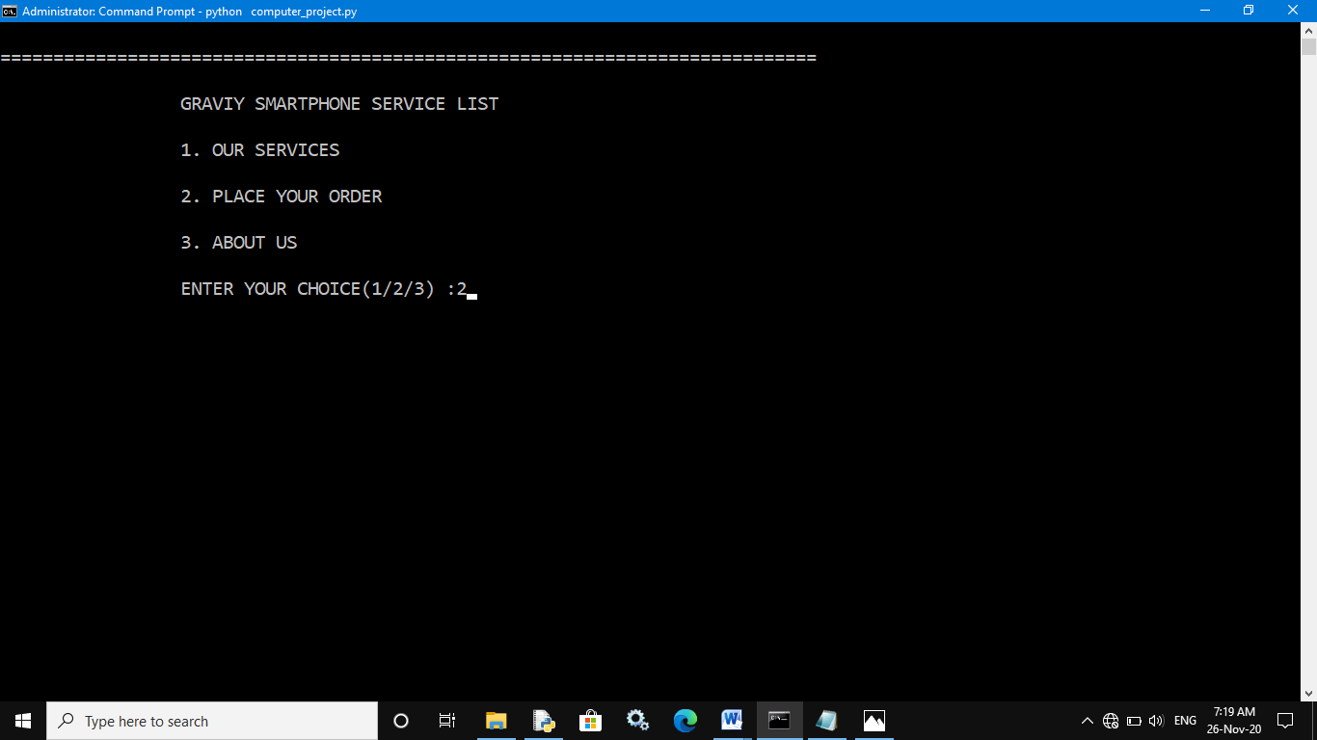

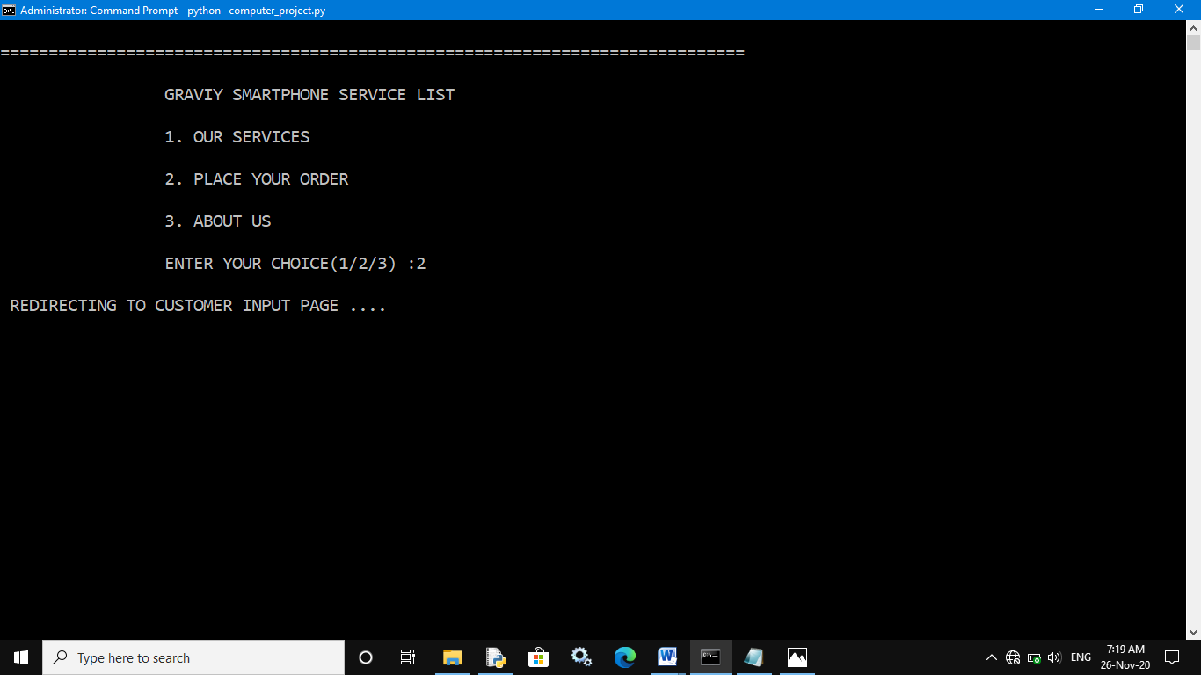

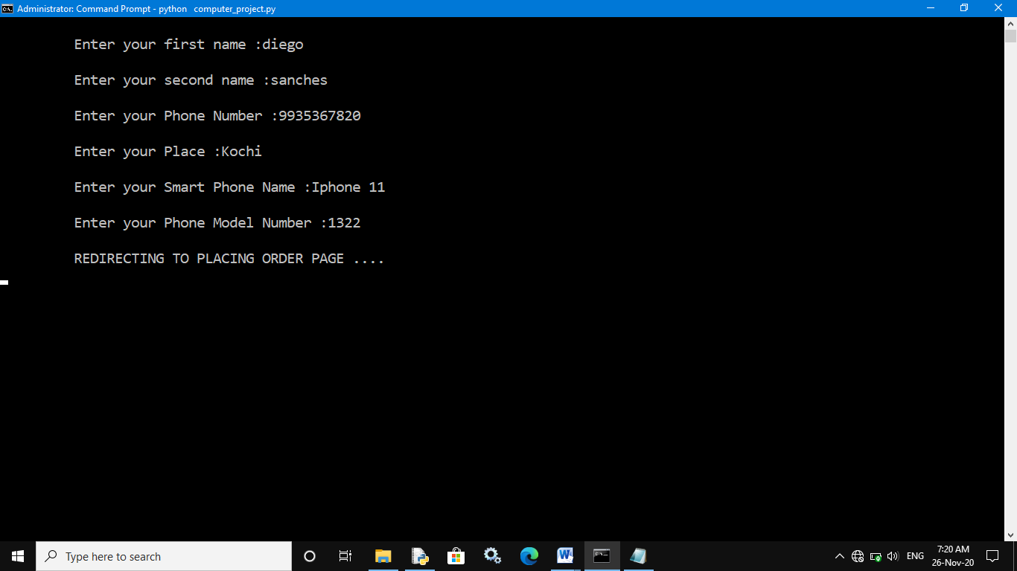

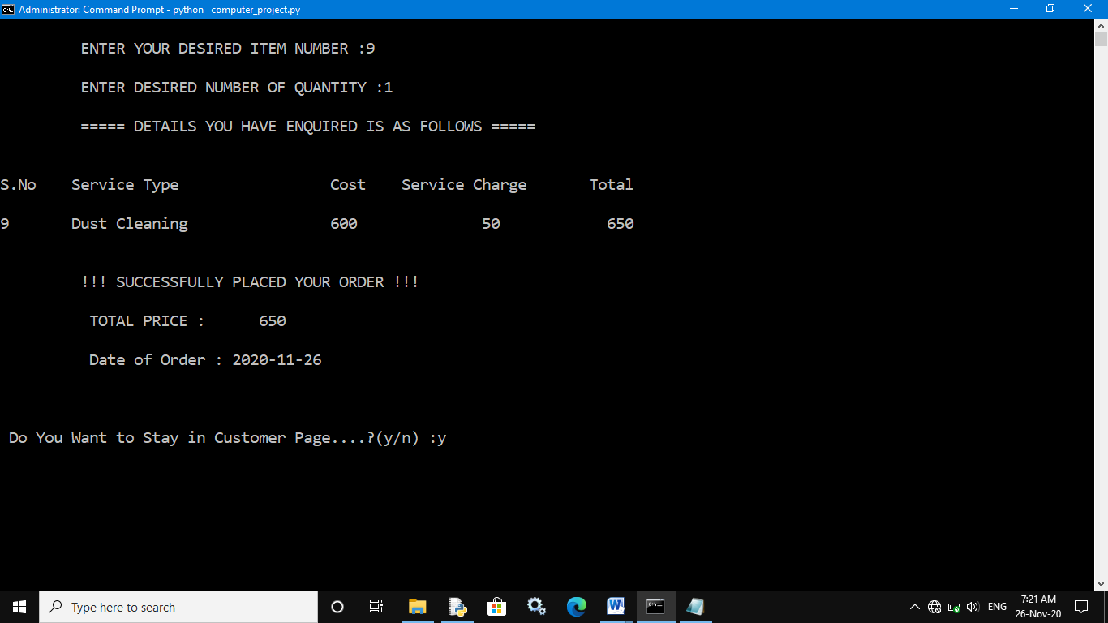

**Third choice:**

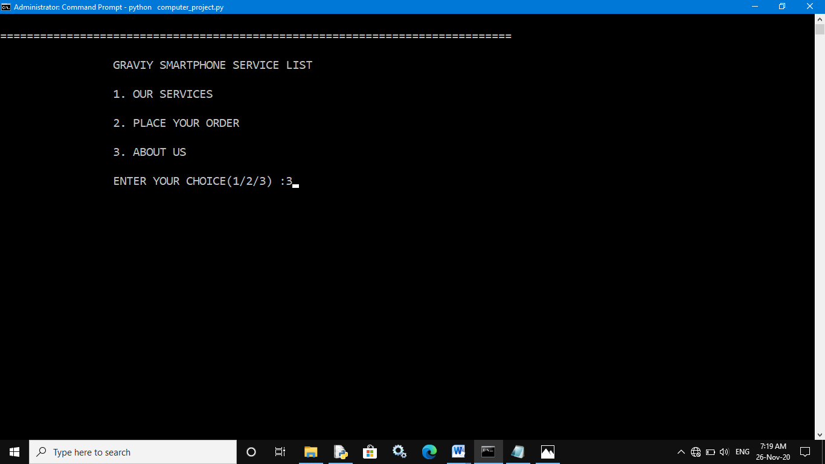

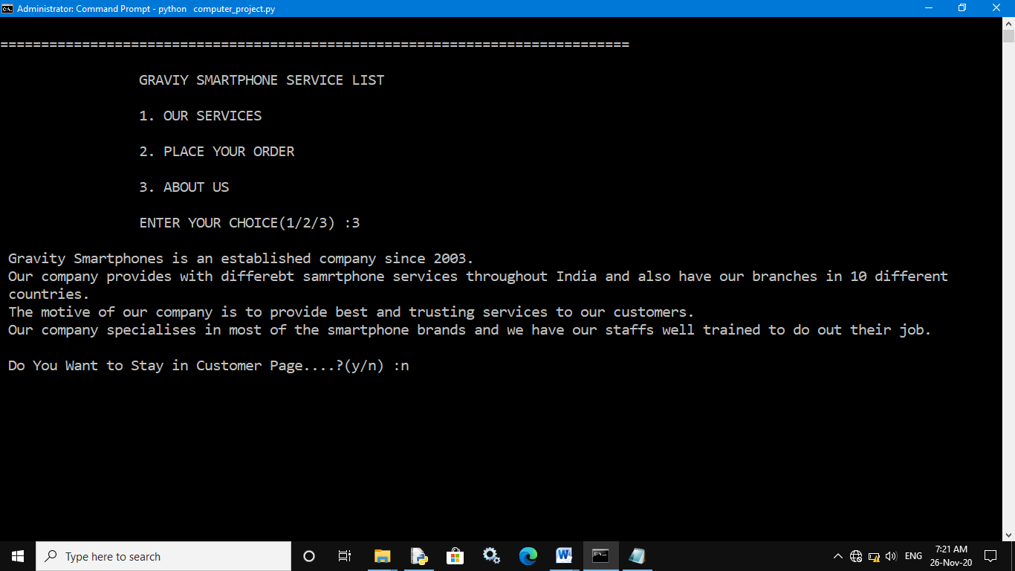

**Exiting from customer menu:**



**Exiting from the program:**

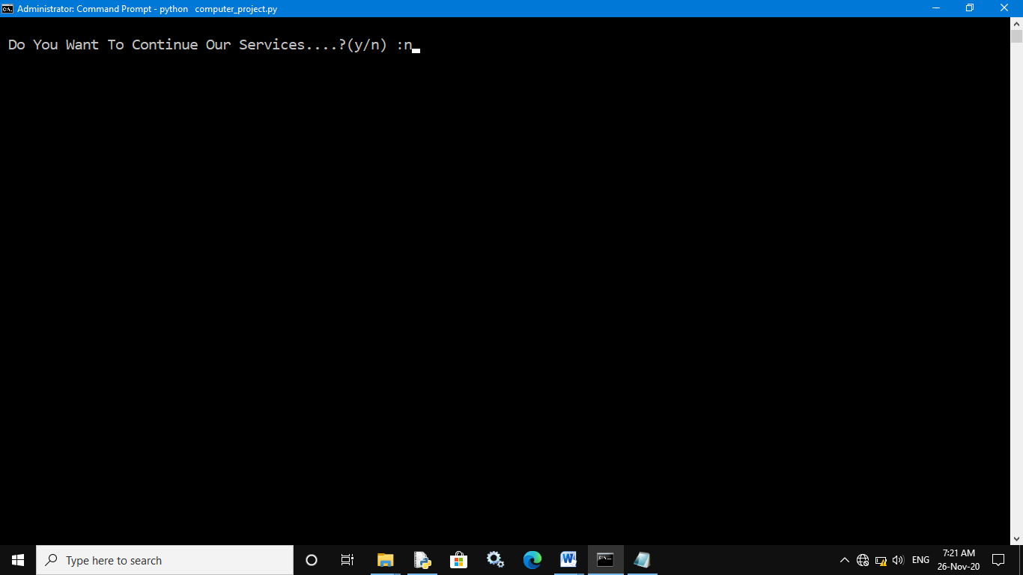

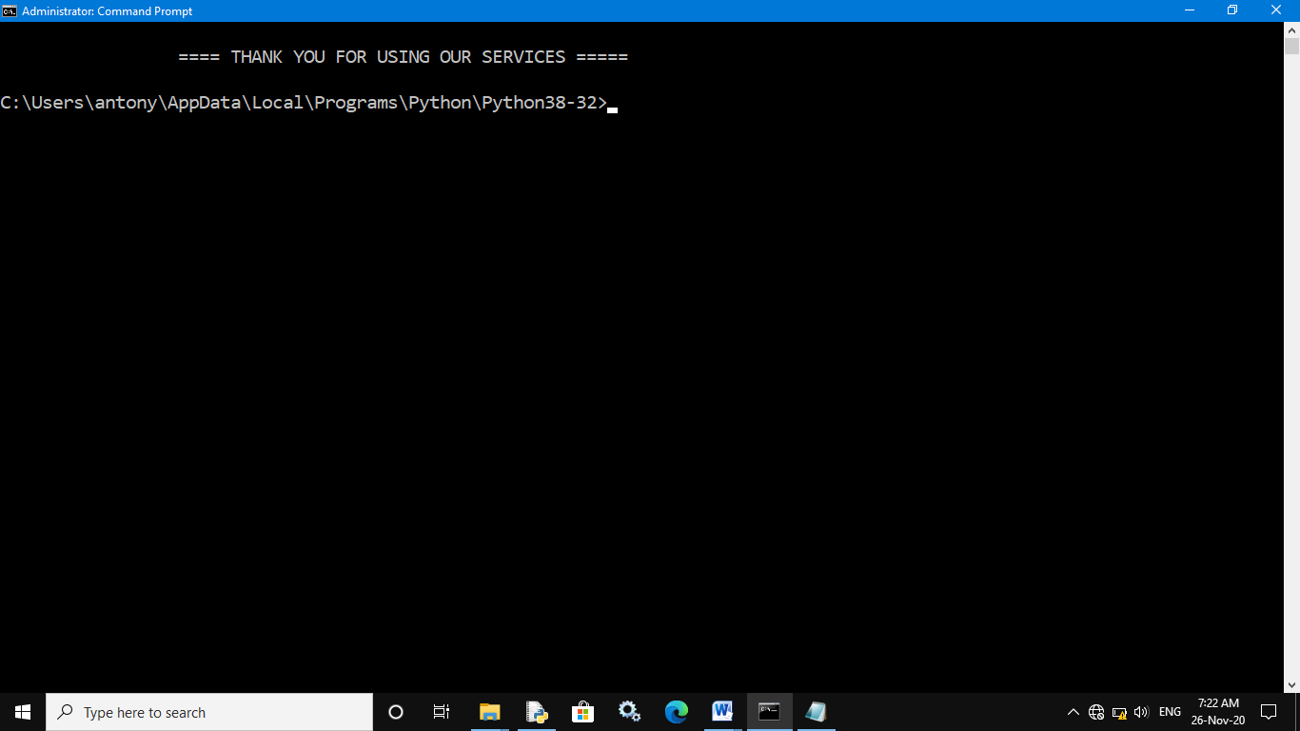

BIBLIOGRAPHY

This project would not have been a success without a below mentioned source which acted as tremendous stream of help to us

COMPUTER SCIENCE WITH PYHTON TEXT FOR CLASS XII

BY PREETI ARORA